Micheal’s Project Report

Git hub Link: https://github.com/MichealFallon/webproject
Initial proposal sketched

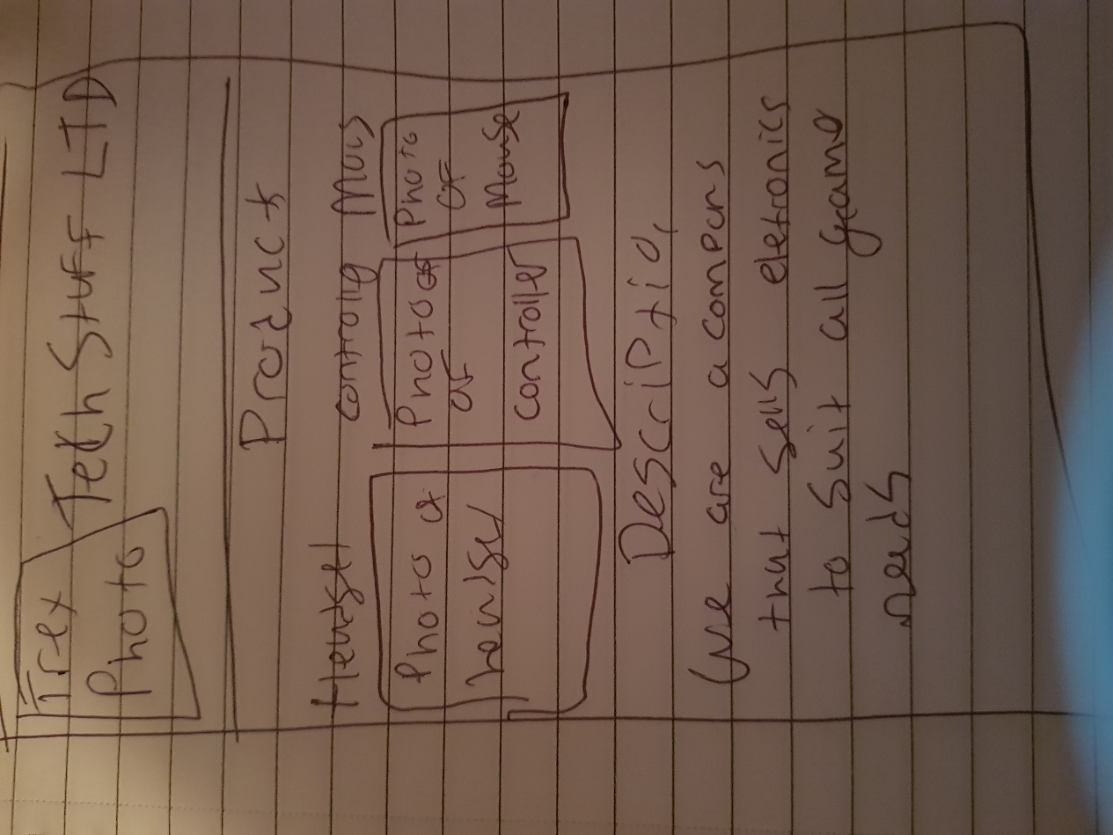

*** GitHub URL Progress upload of web site navigation and 3 pages – Week9
Project Report, Upload zipped folders all website files with report, (place college project on front page, no personal information to be included)
Minimum of 4 HTML Page Website
HTML5 standards and recommended page layout structure (header,main,aside,article,section,footer)
Include Meta data – description, keywords, author - Maximise SEO
Include font family for body of page
Appropriate use of External Style Sheet – Recommended CSS
Appropriate Example using Internal Styling on HTML page (an example)
Appropriate Example using use of inline Styling (an example)
Home page content aligned to each other and visually attractive
Consistency of design on all pages above fold, aligned, use of fonts, colour etc.
Appropriate use of Headings (h1, h2, h3, h4)
Appropriate use of Colours, easy to read and complimentary colours
☐ Include an article or section with css that displays 2 or 3 columns
Clear, consistent and align content on page (reference all sources)
Include public domain images (with at least on image floated with text)
☐ Use of background image
Include table of data/information
☐ Include lists ordered and unordered (different shaped bullet points)
Include favicon and logo on your website
☐ Include a contact form Display values entered in form and include red * beside required/mandatory input fields
Verify data collected on contact form, using get and data attached to URL (Use the method get to display values entered on form will be appended to url and passed to server <form <action="http://foo.com" method="get">)
☐ Include google maps and suitable video
Footer information include Copyright© year and footer menu
Include Internal Links and External Links – Responsive webpages(70%)
Include Appropriate use of CSS Class and Id selectors
Additional Features __________________
W3C HTML & CSS Validator results (in report) https://validator.w3.org/nu/#file
Results of HTML5 Outliner (in report) https://validator.w3.org/nu/#file
Report include Proposal, Declaration of your own work , URL to Github, Rough Sketch of layout design, brief descriptions of the web site its pages and sources for information and Validator results
Website appearance, design and Content https://webdesignledger.com/10-signs-of-a-user-focused-design/ https://webdesignledger.com/20-dos-and-donts-of-effective-web-design/

Description of each page
Page 1: The Home Page
On the home page I have the name of the company (Big Red Gamins LTD) with a picture of a Raptor Beside it. Then I have a navigation bar to get from one page to then next as well as a favicon in the tab name, below that there is a table of the sales amounts of each product, I have some pictures of the products for sale on the website then I have a little bit about the YouTube/Twitch collaborators the company has.
Page 2: Products Page
In this page I also have the company name and logo at the top as well as the navigation bar and favicon, but I also have picture of the products then below them I have the prices for each and a little description of the products.
Page 3: The Collaborators page
On this page I also have the name logo navigation bar and favicon. But on this page, I go through the collaborators that the company as, I show a picture of them and then there is a little paragraph on them and where to find their YouTube/Twitch.
Page 4: The Staff
in this page I also have the name logo navigation bar and favicon. But in this one I have the staff similar to the Collaborators page I show a picture of the staff member and then say a little about what they do for the company

